**Name: Adwait Purao**

**UID: 2021300101**

**Batch: B2/B**

**Experiment no.: 4**

***AIM: To learn use of Cisco Packet Tracer and create a circuit***.

**Theory:**

Cisco Packet Tracer as the name suggests, is a tool built by Cisco. This tool provides a network simulation to practice simple and complex networks.

As Cisco believes, the best way to learn about networking is to do it.

The main purpose of Cisco Packet Tracer is to help students learn the principles of networking with hands-on experience as well as develop Cisco technology specific skills. Since the protocols are implemented in software only method, this tool cannot replace the hardware Routers or Switches. Interestingly, this tool does not only include Cisco products but also many more networking devices.

Using this tool is widely encouraged as it is part of the curriculum like CCNA, CCENT where Faculties use Packet Trace to demonstrate technical concepts and networking systems. Students complete assignments using this tool, working on their own or in teams.

Engineers prefer to test any protocols on Cisco Packet Tracer before implementing them. Also, Engineers who would like to deploy any change in the production network prefer to use Cisco Packet Tracer to first test the required changes and proceed to deploy if and only if everything is working as expected.

This makes the job easier for Engineers allowing them to add or remove simulated network devices, with a Command line interface and a drag and drop user interface.

Engineers prefer to test any protocols on Cisco Packet Tracer before implementing them. Also, Engineers who would like to deploy any change in the production network prefer to use Cisco Packet Tracer to first test the required changes and proceed to deploy if and only if everything is working as expected.

This makes the job easier for Engineers allowing them to add or remove simulated network devices, with a Command line interface and a drag and drop user interface.

Features of Cisco Packet Tracer:

1. Cisco Packet Tracer supports a multi-user system that allows many users to connect various topologies across a computer network. Instructors can also build exercises for students to perform using Packet Tracer.

2. Supports feature expansion via additional programmes that use an API to improve Cisco Packet Tracer's capabilities in areas including curriculum and assessment delivery, gaming, accessibility, and interacting with real-world equipment.

3. The Enhanced Physical Mode transports you to a virtual lab where you can simulate cabling devices on a rack. Refresh key skills such as device placement (Rack & Stack), on-device power switching, device port-to-port cabling (including cable selection and management), troubleshooting, and more.

4. It can be downloaded for free through a Netacad account.

5. It enables its users to simulate the configuration relating to the Cisco routers and can be accessed anywhere anytime.

6. The Network Controller allows you a centralised dashboard to see the network's state, instantly discover and diagnose issues, and push configuration changes to all managed devices at once, whether you use its Web GUI or its APIs. You may also use real-world programmes on your computer to access the Network Controller and run your own infrastructure automation scripts.

7. It can be accessed through unlimited devices.

8. Provides an interactive and self-paced environment.

**Addressing Table**

|  |  |  |  |  |
| --- | --- | --- | --- | --- |
| **Device** | **Interface** | **IP Address** | **Subnet Mask** | **Default Gateway** |
| **R1** | **Fa0/0** | **192.168.1.1** | **255.255.255.0** | **N/A** |
| **S0/0/0** | **192.168.3.20** | **255.255.255.0** | **N/A** |
| **R2** | **Fa0/0** | **192.168.2.1** | **255.255.255.0** | **N/A** |
| **S0/0/0** | **192.168.3.20** | **255.255.255.0** | **N/A** |
| **PC1** | **NIC** | **192.168.1.2** | **255.255.255.0** | **192.168.1.1** |
| **PC2** | **NIC** | **192.168.2.2** | **255.255.255.0** | **192.168.2.1** |

**Q1) How many subnets are needed for this network?**

Ans: 3 subnets are needed for this network.

**Q2) What is the subnet mask for this network in dotted decimal format?**

Ans: 255.255.255.0 is the subnet mask for this network.

**Q3) What is the subnet mask for the network in slash format?**

Ans: /24 is the subnet mask in slash format.

**Q4) How many usable hosts are there per subnet?**

Ans: There are 30 usable hosts per subnet.

Answer the following questions to verify that the network is operating as expected.

**Q5) From the host attached to R1, is it possible to ping the default gateway?**

Ans: Yes

**Q6) From the host attached to R2, is it possible to ping the default gateway?**

Ans: Yes

**Q7) From the router R1, is it possible to ping the Serial 0/0/0 interface of R2?**

Ans: Yes

**Q8) From the router R2, is it possible to ping the Serial 0/0/0 interface of R1?**

Ans: Yes

The answer to the above questions should be yes. If any of the above pings failed, check your physical

connections and configurations.

**Q9) Are there any devices on the network that cannot ping each other?**

Ans: R1 cannot ping the Fast Ethernet Cable on R2.

**Q10) What is missing from the network that is preventing communication between these devices?**

Ans: The network is missing either static or dynamic routing or both that is preventing communication

between these devices.

**Screenshots of packet tracing:**

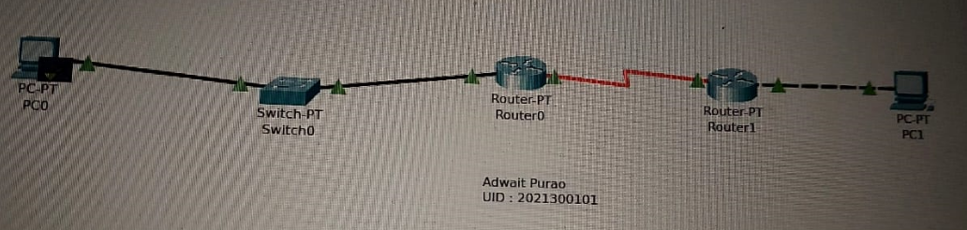

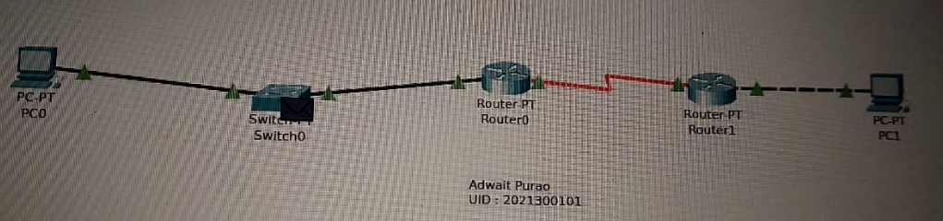

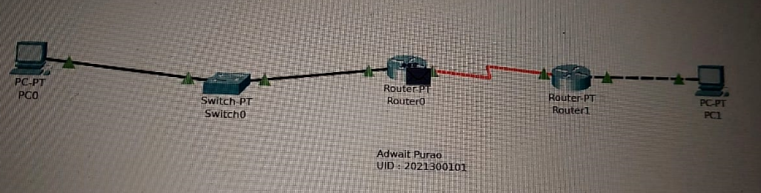

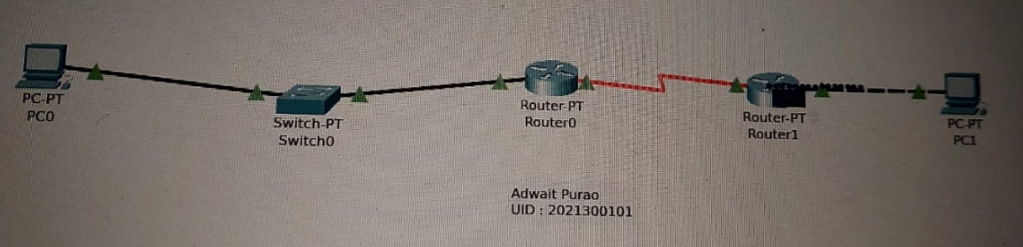

**Conclusion:**

Through our experiment, we gained knowledge and skills in using Cisco Packet Tracer, a software tool used to create virtual networks consisting of various components such as PCs, routers, and switches. We learned how to connect these components using wiring and configure them by assigning IP addresses and subnet masks. By simulating the network, we were able to successfully transmit packets between two PCs. Overall, our experiment allowed us to develop a practical understanding of network configuration and simulation using Cisco Packet Tracer.